DIABETES PREDICTION USING MACHINE LEARNING ALGORITHMS AND HYPERPARAMETER TUNING FOR EXPECTING MOTHERS

D. Manoj Kumar Department of Electronics and Communication Engineering
SRM Institute of Science and Technology, Ramapuram Campus Chennai, India
manojkud1@srmist.edu.in
Vaddepally Punith Kumar Department of Electronics and Communication Engineering
SRM Institute of Science and Technology, Ramapuram Campus Chennai, India
vp5822@srmist.edu.in
R Arthi
Department of Electronics and Communication Engineering
SRM Institute of Science and Technology, Ramapuram Campus Chennai, India
arthir2@srmist.edu.in
Sirimaram Mahidhar Department of Electronics and Communication Engineering
SRM Institute of Science and Technology, Ramapuram Campus Chennai, India
sm6150@srmist.edu.in
Kudithipudi Dhanveer Department of Electronics and Communication Engineering
SRM Institute of Science and Technology, Ramapuram Campus Chennai, India
kd5832@srmist.edu.in
Brahdesh S
Department of Electronics and Communication Engineering
SRM Institute of Science and Technology, Ramapuram Campus Chennai, India
bs5809@srmist.edu.in

Abstract— Diabetes is a chronic disease that occurs when the blood glucose levels in the human body exceed the normal range. If left untreated, diabetes can lead to various health complications. To prevent such complications, early detection and management of diabetes are crucial. In this study, a novel system is proposed that uses hyperparameter tuning in addition to various machine learning algorithms for early detection of diabetes. We also tune the hyperparameters of the algorithms to optimize their performance. The results indicate that the Support Vector Machine algorithm provides the best fit for predicting diabetes. Hyperparameter tuning further improves the performance of this algorithm. Our approach can be used as a decision support tool for healthcare professionals to identify high-risk patients early on and provide appropriate care and management. Our study highlights the potential of machine learning algorithms and hyperparameter tuning for developing accurate and reliable predictive models for diabetes in expecting mothers. These models can aid healthcare professionals in taking preventive measures to improve maternal and child health outcomes.
Keywords— Dataset pre-processing, Data standardization, Performance metrics, Hyperparameter Tuning, Diabetes, Machine Learning.

INTRODUCTION
Diabetes comes under harmful disease due to an increase in excessive blood glucose levels in the human body. Rani et. al(2020) proposed that Diabetes develops when the human body doesn’t produce enough glucose. According to Health Organizations, there are approximately 421 million diabetics around the globe, with an increase in living in small or moderate-revenue countries. These values can be increased up to 490 billion by 2040 [1]. Mir et.al (2018) has proposed this as a movement in the insulin levels, causing abnormal carbs metabolism as well as increasing human blood sugar levels [2]. Diabetes, on the other hand, is prevalent in several profoundly populated countries, and Bharath. As the Bharath population has passed 100 million, the original number of diabetics in the country is 42 million. Mathad et.al (2016) have proposed that it can be reduced, and human lives will be saved if diabetes is detected as early as possible. So, this work visualizes diabetes prediction by considering a variety of diabetes-related characteristics [3]. Machine Learning is a technique that provides numerous categorization and ensemble models from obtained datasets and effective outcomes for knowledge collecting. Such a collection of Data may be used to predict diabetes but, choosing the effective techniques is not so easy. Sonar et.al (2019) has proposed that Model improvement depends on classification techniques such as Decision Tree, KNN, Naive Bayes and SVM algorithms [4]. Hasan et.al (2020) Proposed that Diabetes forecast involving the ensembling of alternate machine learning classifiers for IEEE in 2020. They proposed a good improvement for diabetes pre-assumption where the novel case dismissal, filling the not visible characteristics, Data Standardization, feature decision, K-overlay cross-approval, and different Machine Learning classifiers and MLP are used. Maniruzzaman et.al (2020) has proposed that a machine learning (ML)-based system for anticipating diabetes patients is the major goal of this project [6]. Sisodia et.al (2018) have proposed that ML portrayal calculations are contemplated and assessed during this work on many metrics. On Indians, PIMA Diabetes Database tests are performed. Preliminary outcomes choose the adequacy of the organized construction with a refined precision of 76.30 % utilizing the Naive Bayes characterization calculation. Later, the organized construction with the used ML arrangement calculation can be utilized to expect or analyze different diseases [7]. Moreira et.al (2018) have proposed that spotlights on Nature-Motivated Computation for Getting ready MLP Associations in e-health issues for High-Hazard Pregnancy Care. The usage of a normally moved system, which we have known as PSO, is proposed for diminishing the computational cost of the ANN-based strategy recommended as the MLP, without diminishing its accuracy rate. Considering everything, various frameworks by 26.4% to the degree that precision and 14.9% to the degree that the TPR showed a diminishing of 35.4% in the FPR.
Kumar Dewangan et.al (2015) have proposed that identification of diabetes can K-fold cross-validation and artificial neural networks were used to complete K-nearest neighbour, vector support machine, and categorization algorithm, data mining technique, etc. Using these strategies, try to combine two models to create an ensemble model technique: Multilayer Perceptron with Bayesian classification for the measurement's precision, sensitivity, and specificity diabetes mellitus diagnosis. Barakat et.al (2010) proposal suggests the utilization of support vector machines (SVMs) as a means of diagnosing diabetes. To enhance the interpretability of the SVM's classification decision, an additional explanation module is incorporated into the model. This module helps to transform the "black box" nature of the SVM's model into a clear and intelligible representation of its diagnostic decision. By providing greater transparency and understanding of the diagnostic process, this approach has the potential to enhance the accuracy and reliability of diabetes diagnoses. Healthcare professionals can benefit from a clearer understanding of the contributing factors to the diagnosis, ultimately leading to improved patient outcomes. [10]. Kalyankar et.al (2017) proposal was made to analyze large amounts of diabetic patient data and use machine learning algorithms in conjunction with Hadoop, a distributed computing framework, to make predictions regarding patient outcomes and potential complications. The proposed study aimed to identify patterns in the data that could be used to predict future outcomes and develop models that could assist in treatment planning and decision-making [11]. Dutta et.al (2018) proposal has been put forward to identify the crucial components that contribute to the cause of diabetes. In areas of research where large datasets containing tens or thousands of elements are available, the selection of variables and features has become the primary focus of many studies. Researchers are working to identify the most relevant and informative features from these datasets, which can help in better understanding the underlying mechanisms of diabetes [12].
Joshi et.al (2018) proposal has been put forward to develop a system that can accurately predict the onset of diabetes in patients by combining the results of various machine-learning approaches. The objective of the study is to create a system that can make early predictions of diabetes by utilizing multiple machine-learning algorithms to analyze patient data. By merging the results of different approaches, the proposed system aims to provide more accurate predictions compared to using a single machine learning approach. [13]. Kavakiotis et.al (2017) proposals objective is the study is to analyze the different ways in which machine learning techniques can be applied to improve the understanding of diabetes and its related complications [14]. Nithya et.al (2017) has proposed that an examination of several machine learning tools, and prediction algorithms is presented in this work [15]. Bothra et.al (2021) has proposed that a venture was carried out on the diabetes forecast model utilizing ML calculation for better arrangement forecast [16]. Mujumdar et.al (2019) has proposed a task to improve the management of diabetes by developing a diabetes prediction model that includes typical components such as glucose, weight history, age, insulin, and other external variables responsible for diabetes. The new dataset used in the study supports grouping precision, unlike the old dataset [17]. Pradhan et.al (2021) proposed a study involved implementing machine learning algorithms, such as Decision Tree (DT), Random Forest (RF), Naive Bayes, Artificial Neural Network (ANN), Support Vector Machine (SVM), and Logistic Regression (LR), for predicting diabetes. [18]. Mitushi et.al (2020) has proposed a classification using machine learning, and outfit strategies on a Cagle dataset to foresee diabetes. that is, KNN, LR, and DT, SVM, GB and RF. When compared to other models, the accuracy varies for each model. The Venture study demonstrates how the model may accurately predict diabetes by providing an exact or superior accuracy model [19]. Sarwar et.al (2018) have proposed that Six distinct machine learning algorithms are employed in this research to address predictive analytics in healthcare. The effectiveness and precision of the used algorithms are explored and contrasted [20].
- BLOCK DIAGRAM
The Proposed Work aims to learn Five different ML classifiers used to anticipate diabetes. It also portrays the methodology proposed to improve accuracy further. The Novelty of the Proposed Work is to identify the best model through mentioned performance metrics using Hyperparameter Tuning. There are two distinct sections to the proposed work. The first section focuses on determining the performance indicators for various ML algorithms. The improvisation of performance metrics following Hyper Parameter Tuning is the subject of the second section. The Five techniques utilized are portrayed under. The results show an estimation for the machine learning Model. Then, at that point, the model can be utilized for expectation. The below-mentioned Fig.1 explains the flow process of the Proposed Work.
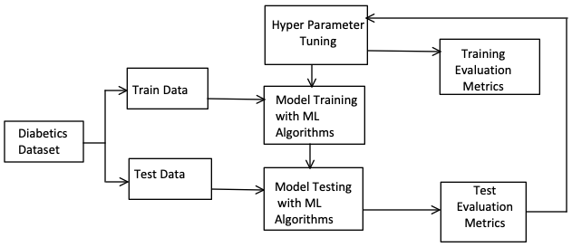
Fig.1 Flow Diagram
- Data Description
The Proposed Work analyses a dataset with 768 data points and nine attributes is the suggested effort. These characteristics include Diabetes Pedigree Function, Age, and Outcome, as well as Pregnancy, Glucose, Blood Pressure, Skin Thickness, Insulin, and BMI. The study concentrates on the first five datasets out of the 768 to find pregnant women who may have diabetes. Based on family history, the Diabetes Pedigree Function (DPF) result in the dataset predicts the chance of having diabetes. The result is classed as 0 if the DPF is less than 0.5; otherwise, it is rated as 1. The analysis's findings show whether the subject is diabetic or not; a result of 0 indicates that the subject is not diabetic, while a result of 1 indicates that the subject is diabetic.
- Data Preprocessing
During the data pre-processing stage, missing values in the dataset were addressed by removing them and inputting the mean value in their place. The pre-processing technique is mainly used to put it another way, whenever data is gathered from several sources, and it is accumulated in crude configuration, that makes examination unimaginable.
- Data standardization
The process of scaling data so that its values are centered on an average of the unit standard deviation is referred to as "data standardization." This procedure seeks to adjust the data to a standard normal distribution, which is an average distribution with an average of 0 and a standard deviation (SD) of 1. It is helpful to look at how standardization impacts some data to better comprehend its effects. All data are converted into standardized quantities within -1 and 1 throughout this procedure. Any empty values in the set of data were deleted before standardization and swapped with the average value.
- Training and Testing of data
In machine learning algorithms, a training dataset is used to train the model to perform various tasks. Features taken from the set of training parameters are used to train the model. For sentiment analysis, individual words or sequences of sequential words are extracted from tweets. The training set is then labelled with appropriate tags to help the model learn from the features.

- Hyperparameter Tuning
For a machine-learning algorithm to use the best collection of hyperparameters, hyperparameter tuning is a critical step. These hyperparameters control the learning experience of the model and can significantly impact its training time, efficiency, and accuracy. To perform Hyperparameter Tuning, multiple trials are executed with different hyperparameter values within defined boundaries. In the proposed work, various machine learning algorithms were evaluated using performance metrics such as Accuracy, Precision, Recall, and F1-Score. The performance metrics were further improved through Hyperparameter Tuning, and the results are discussed below.

- RESULTS
3.1 The performance metrics of different machine learning algorithms were evaluated before and after hyperparameter tuning to assess their effectiveness in predicting diabetes.

Fig.2 shows the percentage Accuracy over various Machine Learning Algorithms. The graph shows that the SVM algorithm has better accuracy of 85% compared to DT, KNN, RF and NB before hyperparameter tuning. The reason is SVM’s better accuracy is that it can maximize the distance from the nearest data points of all the classes obtained during training and testing datasets when compared to other algorithms. The purpose of hyperparameter tuning is to control the growing experience of machine learning models. The obtained accuracy of 88% for SVM after the hyperparameter tuning by satisfying the maximization of distance to the nearest data points as available in the data set.

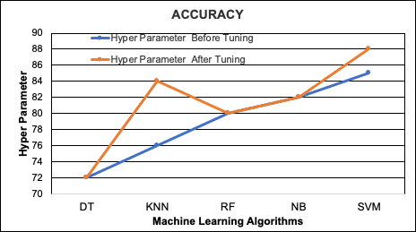
Fig.2 Accuracy
In Fig.3, the obtained precision for various algorithms shows that SVM has got good precision percentage when compared to the other machine learning algorithms. It is seen that SVM has got 85% precision, before hyperparameter tuning, the machine learning algorithm prioritizes maximizing the proximity to the nearest data points, such as accuracy and calculates the number of instances in which the predicted positive class corresponds to the true positive class. SVM obtained 86% but before hyper tuning, it obtained only 85% after hyperparameter tuning. The difference justifies that the hyperparameter tuning elevates to a growth of 1% more for SVM.
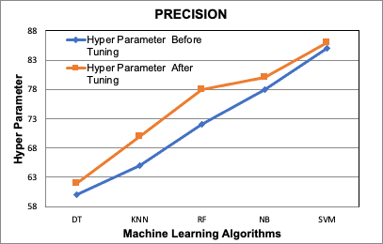
Fig.3 Precision
Fig.4 shows that the Recall for Naïve Bayes is 75% when compared to the other machine learning algorithms before hyperparameter tuning. It has been proved that NB detects more positive samples by justifying with the available data sets are more probabilistic and scalable to several predictors. For the after-hyperparameter tuning process, the Recall percentage for SVM improved by 76%. It is seen that NB has a better percentage of improvement while after the hyperparameter tuning SVM is better.

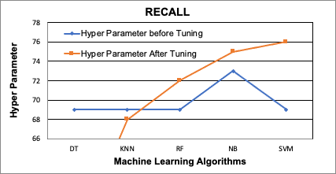
Fig.4 Recall

Fig.5 shows F1 score percentage variations among the machine learning algorithms. Before tuning, the SVM model achieved a 76% F1 score, indicating that the harmonic mean of precision and recall was satisfied. SVM obtains 80% of the score after the hyperparameter tuning whereas it is 76% before tuning. The difference of 4% of improvement during the hyperparameter tuning achieves better harmonics for SVM.
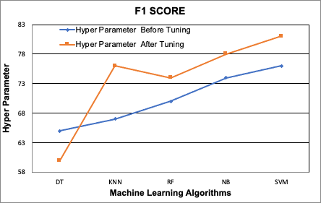
Fig.5 F1 score

SVM outperformed other machine learning methods in terms of precision, recall, accuracy, and F1 score after being tested against the diabetes dataset, making it the most suitable model for predicting diabetes. Moreover, there was a notable improvement in performance after applying hyperparameter tuning.

3.3. Best Model
After evaluating multiple machine learning algorithms for the estimation of diabetes using the available dataset, it can be concluded that SVM outperforms other models in terms of accuracy, precision, recall, and F1 score. As depicted in Fig.6, SVM is the most suitable model for diabetes prediction. The graph demonstrates a substantial improvement in the model's performance after hyperparameter tuning, as illustrated in Fig.6.

Fig.6 Best Model
- CONCLUSION
Although preventive measures have been implemented to detect and manage diabetes at an early stage, the proposed work aims to improve the performance of the classifier in identifying diabetes among pregnant women. The study validates the performance metrics of various machine learning algorithms before and after hyperparameter tuning, resulting in a better prediction of the SVM model for diabetic prediction among expectant mothers. The proposed approach achieved a 4% improvement in performance metrics in predicting the presence of diabetes, using a dataset exclusively for pregnant women. In the future, the proposed work could be extended to automate the prediction of diabetes and prevent the disease using the available dataset.
REFERENCES
- Rani, KM Jyoti. "Diabetes Prediction Using Machine Learning." International Journal of Scientific Research in Computer Science Engineering and Information Technology 6(2020): 294-305.

- Mir, Ayman, and Sudhir N. Dhage. "Diabetes disease prediction using machine learning on big data of healthcare." 2018 fourth international conference on computing communication control and Automation (ICCUBEA) IEEE,2018.

- Mathad, Bhagyashree S., and S. M. Joshi. "Analysis of Diabetic Data Using R." Bonfring International Journal of Software Engineering and Soft Computing Special Issue on Advances in Computer Science and Engineering and Workshop on Big Data (2016): 104-108.

- Sonar, Priyanka, and K. JayaMalini. "Diabetes prediction using different machine learning approaches." 2019 3rd International Conference on Computing Methodologies and Communication (ICCMC) IEEE, 2019.

- Hasan, Md Kamrul, et al. "Diabetes prediction using ensembling of different machine learning classifiers." IEEE Access 8 (2020): 76516-76531.

- Maniruzzaman, Md, et al. "Classification and prediction of diabetes disease using machine learning paradigm." Health information science and Systems 8.1 (2020): 1-14.

- Sisodia, Deepti, and Dilip Singh Sisodia. "Prediction of diabetes using classification algorithms." Procedia computer science 132 (2018): 1578-1585.

- Moreira, Mário WL, et al. "Nature-inspired algorithm for training multilayer perceptron networks in e-health environments for high-risk pregnancy care." Journal of medical systems 42.3 (2018): 1-10

- Kumar Dewangan, Amit, and Pragati Agrawal. "Classification of diabetes mellitus using machine learning techniques." International Journal of Engineering and Applied Sciences 2.5 (2015): 257905. [ISSN: 2394-3661, Volume-2, Issue-5, May 2015]

- Barakat, Nahla, Andrew P. Bradley, and Mohamed Nabil H. Barakat. "Intelligible support vector machines for diagnosis of diabetes mellitus." IEEE Transactions on information technology in Biomedicine 14.4 (2010): 1114-1120.

- Kalyankar, Gauri D., Shivananda R. Poojara, and Nagaraj V. Dharwadkar. "Predictive analysis of diabetic patient data using machine learning and Hadoop." 2017 international conference on I-SMAC (IoT in social, mobile, analytics and cloud) (I-SMAC). IEEE, 2017.

- Dutta, Debadri, Debpriyo Paul, and Parthajeet Ghosh. "Analysing feature importances for diabetes prediction using machine learning." 2018 IEEE 9th Annual Information Technology, Electronics and Mobile Communication Conference (IEMCON). IEEE, 2018.

- Joshi, Tejas N., and P. P. M. Chawan. "Diabetes prediction using machine learning techniques." Ijera 8.1 (2018): 9-13.

- Kavakiotis, Ioannis, et al. "Machine learning and data mining methods in diabetes research." Computational and structural biotechnology journal 15 (2017): 104-116.

- Nithya, B., and V. Ilango. "Predictive analytics in health care using machine learning tools and techniques." 2017 International Conference on Intelligent Computing and Control Systems (ICICCS). IEEE, 2017.

- Bothra, Rishab. "Diabetes prediction using machine learning algorithms”, Vol 6, 2021/09/01, 10.33564/IJEAST. 2021.v06i05.020, International Journal of Engineering Applied Sciences and Technology.

- Mujumdar, Aishwarya, and V. Vaidehi. "Diabetes prediction using machine learning algorithms." Procedia Computer Science 165 (2019): 292-299.

- Pradhan, Gaurav, Ratika Pradhan, and Bidita Khandelwal. "A study on various machine learning algorithms used for prediction of diabetes mellitus." Soft Computing Techniques and Applications. Springer, Singapore, 2021. 553-561.

- Mitushi, Soni, and Varma Sunita. "Diabetes prediction using machine learning techniques." International Journal of Engineering Research & Technology (IJERT) (2020).

- Sarwar, Muhammad Azeem, et al. "Prediction of diabetes using machine learning algorithms in healthcare." 2018 24th international conference on Automation and Computing (ICAC). IEEE, 2018.

